120  SWG-HCM-FS | Annex 2B  Bratislava  8-9 April 2008 | HCM-FS(08)03

Subject: HCM Agreement Annex 2B: The use of Annex 2B file and ITU T11 Form for coordination with other services

Source: SVN

Date: 26 March 2008

Summary
SVN Administration supports document HCM-FS(08)02 from France on differences between field needed in Annex 2B and T11. In our document is given the complete procedure with concrete examples and supporting files. The differences in procedure (and data) between bands for terrestrial services only and bands shared with FSS, are indicated.

1. How to create ITU T11 file using ITU software
ITU has developed software called FXMDCap.exe (Attachment 1) for generating electronic file in T11 form.
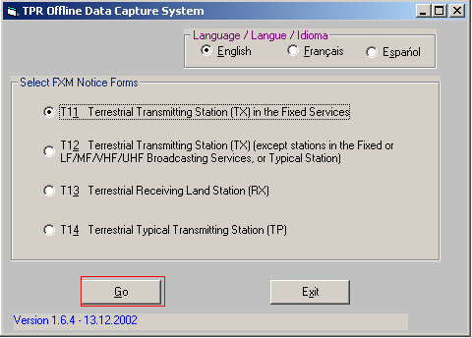
After click on Go, a *.txt file is generated (T11-2008326-1127.txt) and an input form opens:
For Addition, first notification of FX services we have to check:
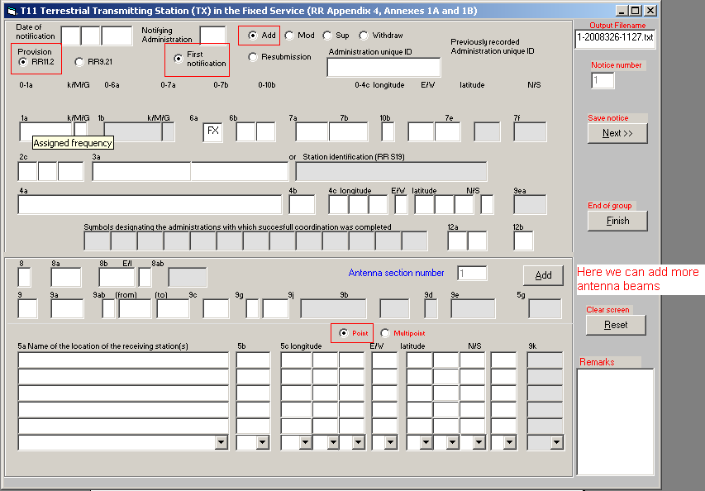
Then data has to be filled in as described in HCM-FS(08)02. We usually put fixed links as Point – Point, therefore Point has to be checked and only one antenna beam is needed.
Example: *.csv file
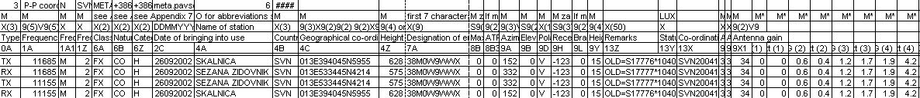
Directly only Txs can be coordinated.
For the date of notification you have to put current year (2008).
9C Antenna beamwidth is 9X_CP_ANGLE where 9X_CP_Attenuation reaches 3dB. (If there is no data, we can extrapolate form 9X Co-polar Antenna Pattern.
First 2 lines: SKALNICA – SEZANA ZIDOVNIK
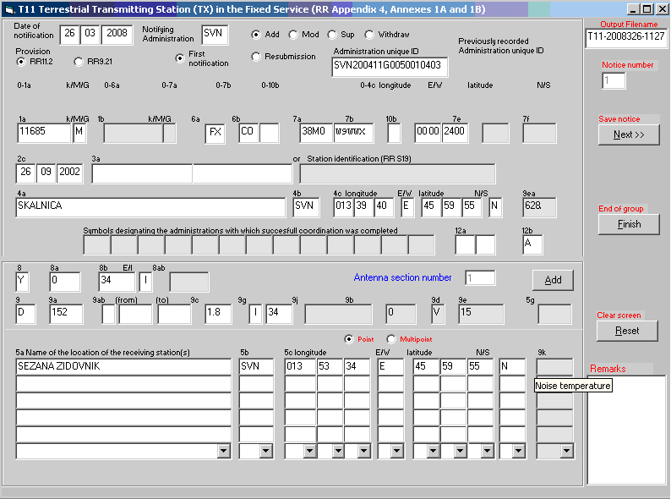
Next, then other 2 lines SEZANA ZIDOVNIK – SKALNICA are filled in:
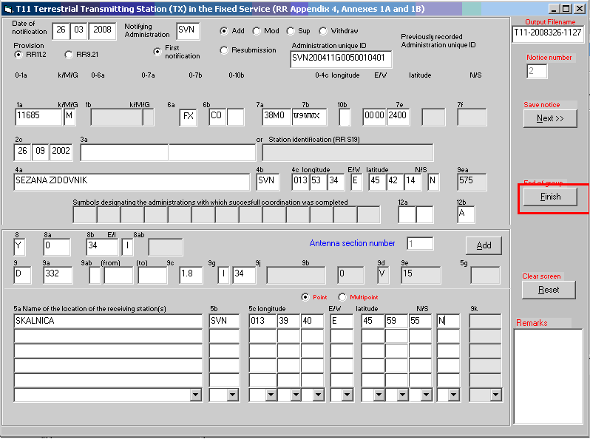
The result is electronic file: T11-2008326-1127.txt (Attachment 2)
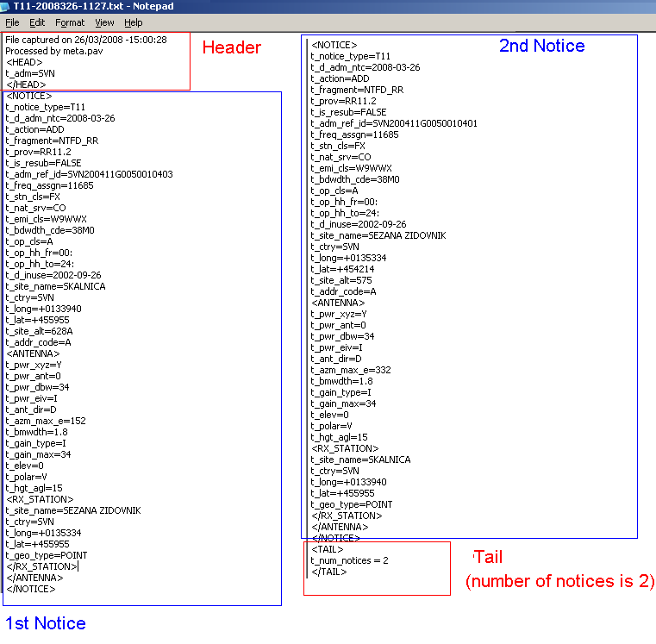
The file is checked by an ITU program called TERANV, which is available on TERASYS BRIFIC DVD.
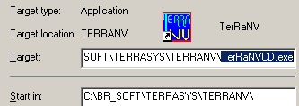
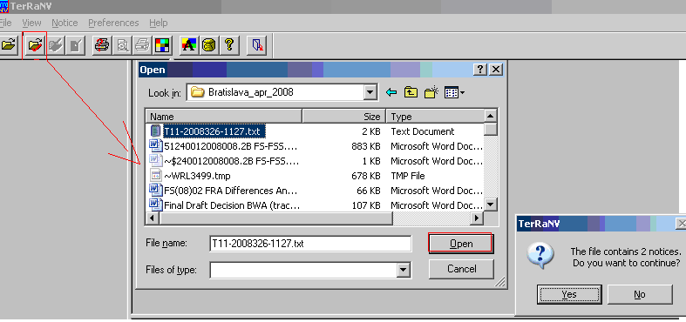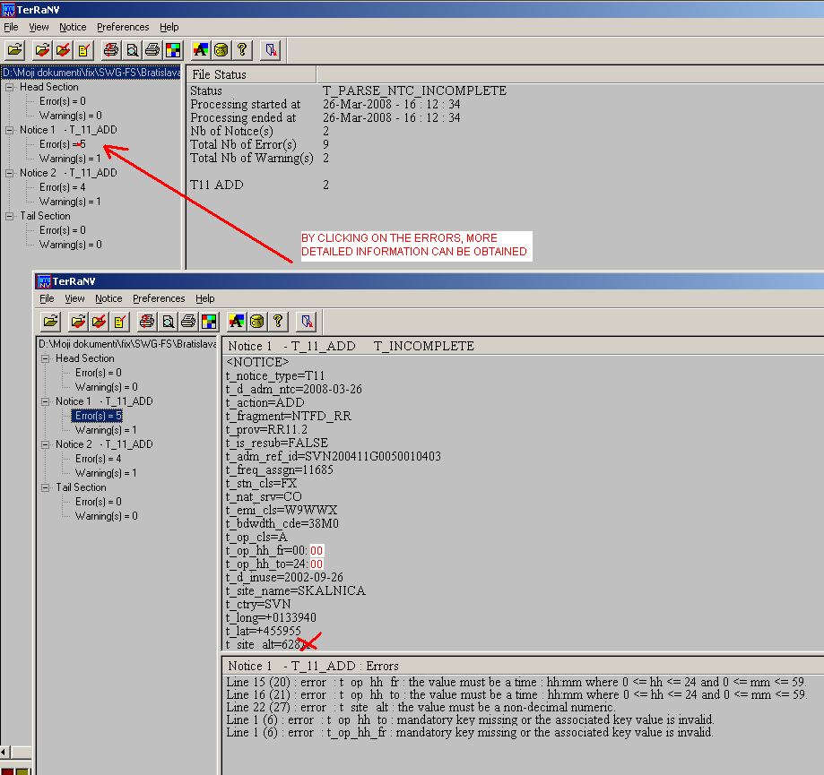
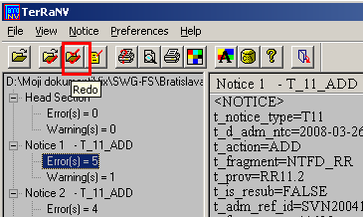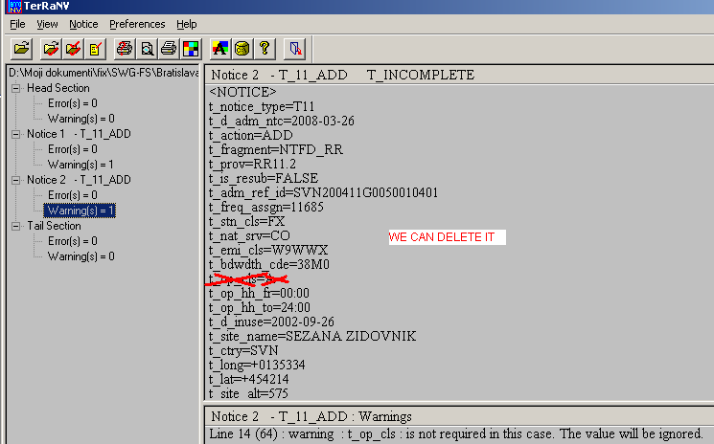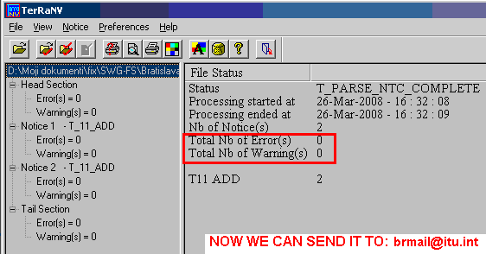
There is a rule sending data to the ITU:
The group of identifying elements for T11 notices are Assigned Frequency, Class of station, Class of Emission, Bandwidth code, Operation class, Operation Hours, and Geographical Coordinates of Transmitting site.
If there are several links from one location with the same Tx Frequency and all the other identifying elements, the ITU software treats them as doubles. In such cases Administration is asked by ITU to consider merging the antenna sections under one notice instead of separately notifying as two or more notices. Otherwise all previous doubles are removed by the last one.

In such cases there are two options:
- to check Point – Point and add as many antenna beams + receiver data as there are directions (usual way) We tested up to 8 antenna beams and it works: T11-2007131-941test.txt – Attachment 3
Example:
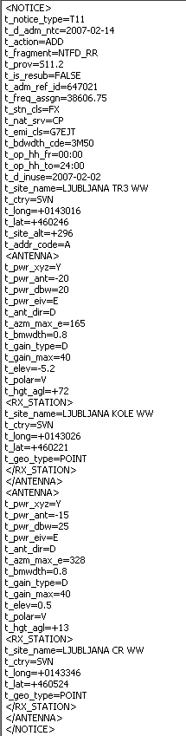
- For 3 and more antenna beams we can create P-MP, with more general radiation pattern and add only the coordinates for the receiving points. In practise we did this way only for one special case, where we had 6 links:
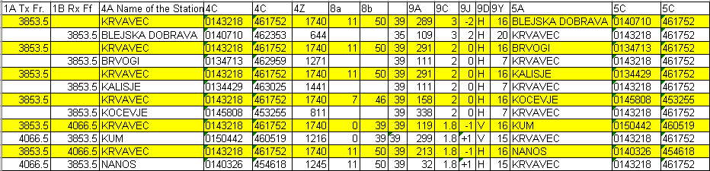
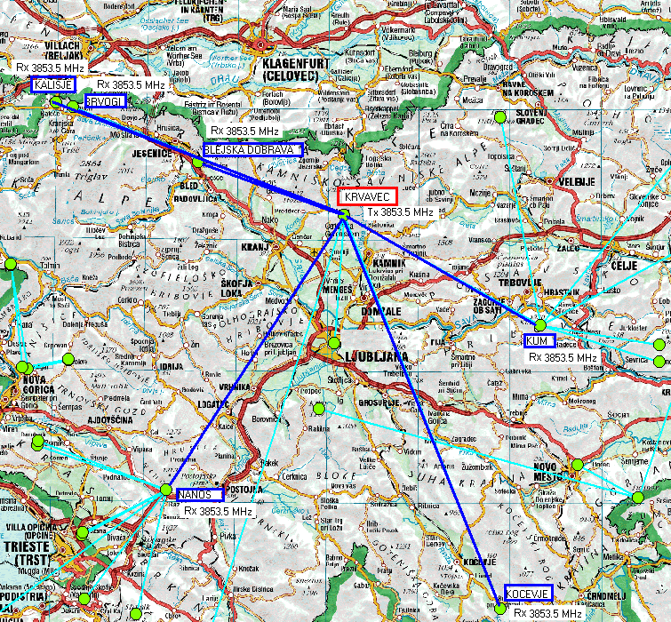

Attachment 4: T11-2007131-941 PMP example.txt
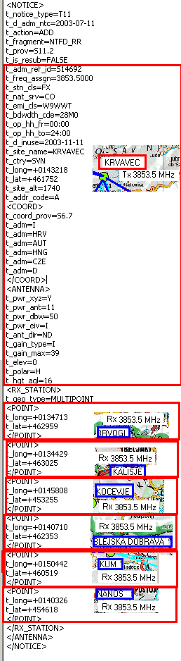
2. The difference in procedure between
In bands shared with satellite services a coordination procedure in accordance with RR6.7 and RR 9.18 or RR 9.16 has to be completed before notifying in accordance with RR11.2.
For other frequency bands it can be done in paralell.
There is as well a difference in notice describtions in T11 files:
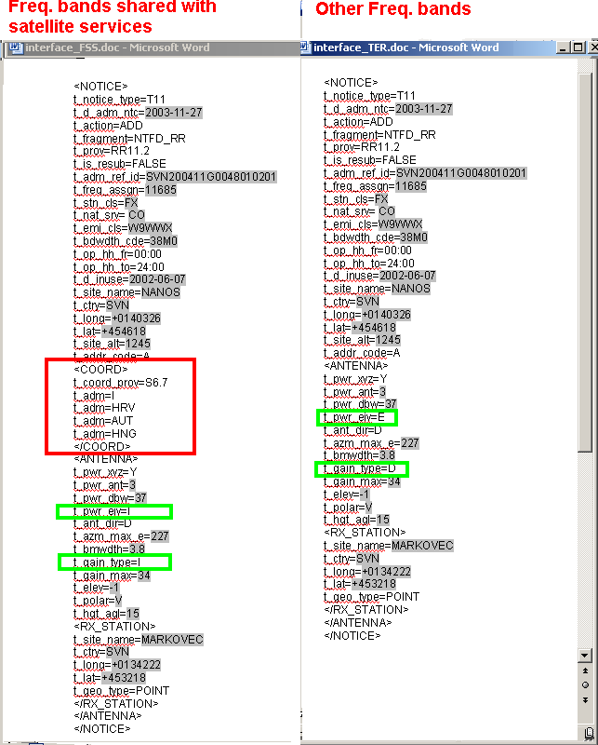
3. Interface to create ITU T11 file out of HCM Annex 2B File (via MS. Excell and MS. Word)
The file interface.xls (Attachment 5) consists of five worksheets: INPUT ANNEX 2B FILE, SORTED INPUT 2B, DOUBLES, INTERFACE, Copy_INTERFACE.
In INPUT ANNEX 2B FILE *.txt file in Annex 2B format is pasted. In SORTED INPUT 2B data from INPUT ANNEX 2B FILE is sorted by field 13X. In worksheet DOUBLES from INPUT ANNEX 2B FILE is sorted by fields 1A, 4A and 7A to identify doubles. Only Tx doubles are critical.
In ITU T11 txt file fields SVN200423G0478010401 and SVN200423G0481010401 will have to be merged one Point – Point transmitter and 2 antenna beams + 2 receiver data.
The doubles are marked as well in SORTED INPUT 2B worksheet. It is easier if we put these 2 links one after an other, and at the end.
Comments regarding interface:
- In type of power might be discrepancy between 2B and T11, because for FX services, Y (mean power) is usually used. Value X (peak envelope power) is used when coordinating radars.
- Power to the antenna 8a
8a = 8B(8a)Power to antenna– 9L Branches and line losses
- Radiated power 8b
8b = 8B(8a)Power to antenna + 8B3 ATPC + 9X1(9j) Antenna gain
- Antenna beamwidth 9c: the best way is to put a real value
Definition from RR AP4: ITEM 9C – Angular width of radiation main lobe (beamwidth)
The total angle measured horizontally in a plane containing the direction of maximum radiation, in degrees, within which the power radiated in any direction does not fall more than 3 dB below the power radiated in the direction of maximum radiation.
It is possible to calculate 9C by taking value: 2 x 9X_CP_ANG (4), because in Annex 2B, Appendix 13, the first attenuation above 3dB is 9X_CP_Att (4).
In the worksheet INTERFACE all transformations of fields are done. The whole sheet has to be copied in the worksheet Copy_INTERFACE by Copy, Paste special (values). Data, sort by n ascending. The data with n> 1000000 is deleted.
File interface.xls has to be saved and closed.
Depending on the frequency band the appropriate file interface_FSS.doc or interface_TER.doc is opened. The right data source has to be connected interface.xls, worksheet Copy_INTERFACE.
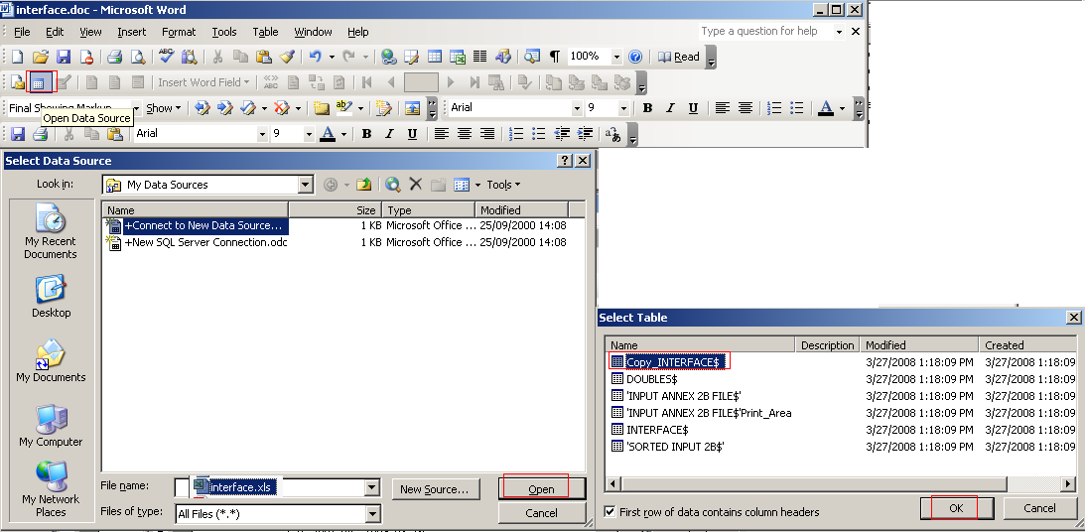
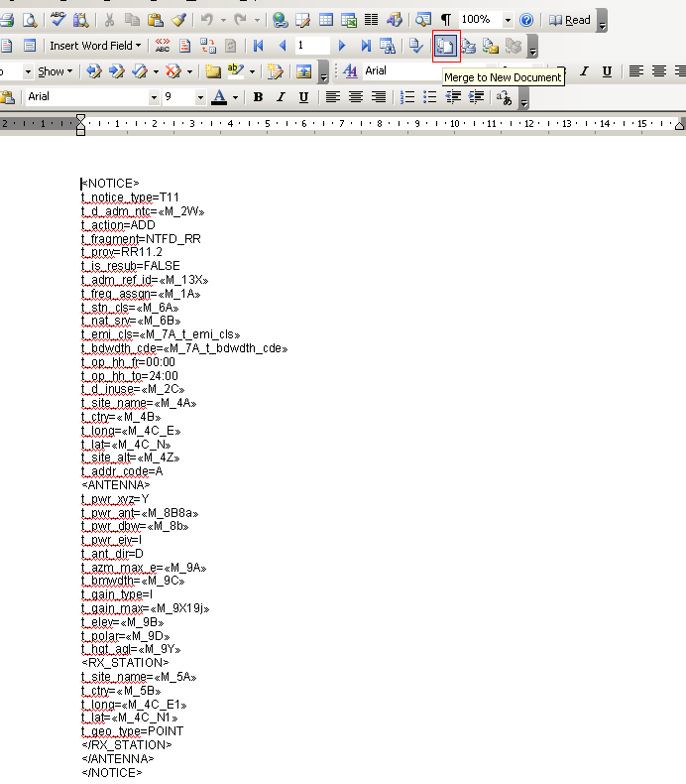
Byclicking merge to a new document we get all needed records from Copy_INTERFACE . In our example we have got first 3 links in a frequency band shared by satellite services, links from 4 to 23 in other frequency bands. The last 2 links are doubles.
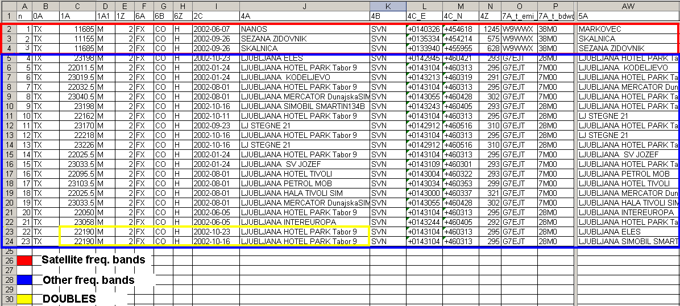
First we open interface_FSS.doc (Attachment 6), click merge document, select records 1 to 3. Then we select all and paste into T11-2008328-1127.txt (Attachment 8) generated by FXMDCap.exe, between Header and Tail:
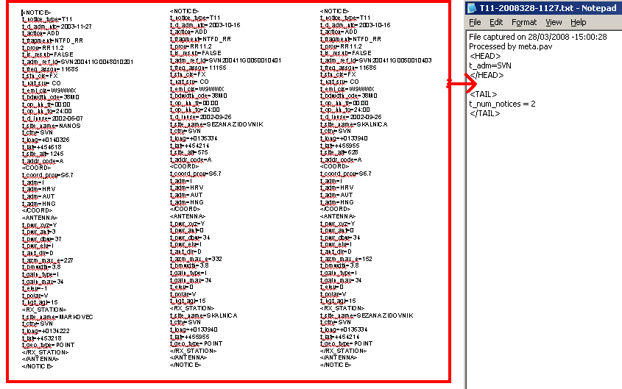
Then we open interface_TER.doc (Attachment 7), click merge document, select records 4 to 23. Then we select all and paste into T11-2008328-1127.txt file (Attachment 8) generated by FXMD.Cap.exe, between Header and Tail:
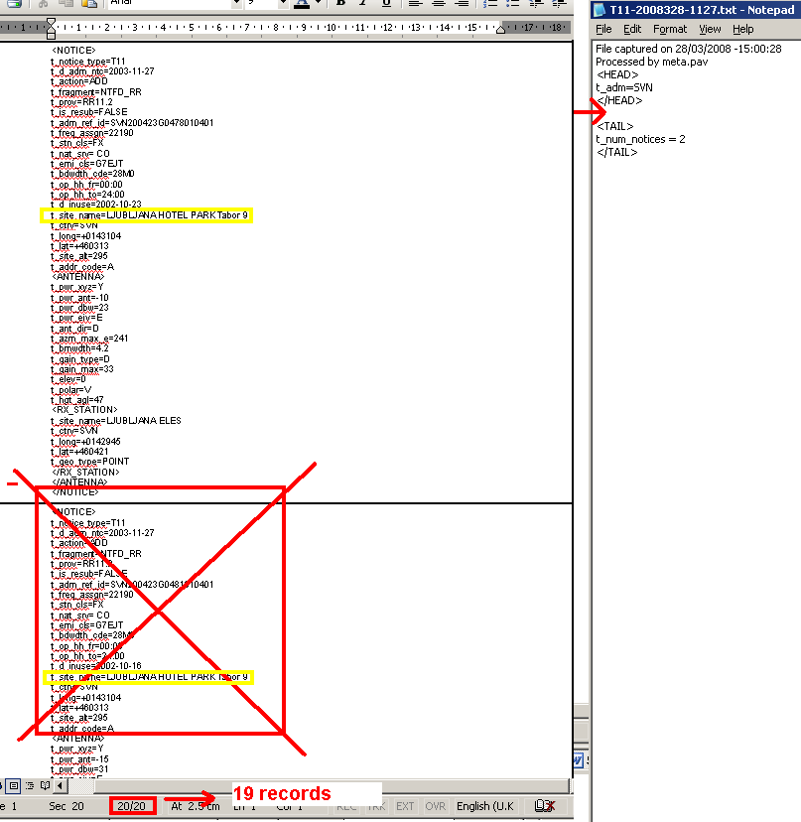

We have got 20 notices, but the last 2 are doubles, therefore we have to merge last two notices, by striking out superfluous part.
In the end the number of records in tail has to be corrected: 2 -> 3+19=22.
The file is saved as T11-2008328-1127_end.txt (Attachment 9) and checked by TERANV program and the procedure is completed.

Attachments:

- FXMDCap.exe
- T11-2008326-1127.txt
- T11-2007131-941test.txt
- T11-2007131-941 PMP example.txt
- interface.xls
- interface_FSS.doc
- interface_TER.doc
- T11-2008328-1127.txt
- T11-2008328-1127_end.txt

